|  |
| --- |
| CAPGEMINI |
| Carton in shipped status but pinned to open shipment/Close shipment |
|  |
|  |
| |  |  |  | | --- | --- | --- | | **Document Update** | **Updated By** | **Date** | | Created By | HussainBasha Pathan/Sindhooja | 04/28/2016 | | Reviewed By | Sabita Prasad | 05/02/2016 | |
|  |

|  |
| --- |
|  |

**Task name:** Carton in shipped status but pinned to open shipment

***Carton in shipped status but pinned to open shipment.***

**Severity:** High

**Description:** An email alert will trigger from SCI, saying that “Carton in shipped status but pinned to open shipment”. This is due to the shipment is in open status while the cartons associated with it is in 90 (shipped) status. The sample case email attached here for reference.



**Checks to be done:**

* Once alert is triggered, check the shipment status in db it will be in open status (i.e., Accepted 60 status).
* Check the cartons status associated with the shipment, it will be in 90 (shipped) status

**Scenario 1:**

**Resolution steps:**

**Step 1:** Check shipment status with the shipment ID provided in mail.

**Select *from shipment where tc_shipment_id = 'CS14018398';**

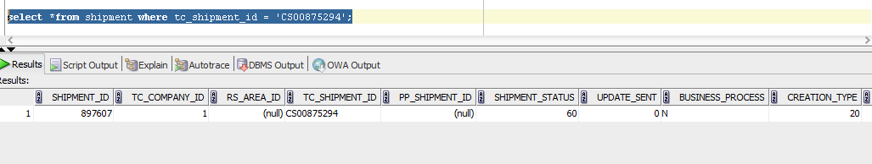

* Shipment is in 60 (Accepted) status

**Step 2:** Check oLPN status attached to above shipment.

**Select *from LPN where tc_lpn_id = '00000197181320203380';**

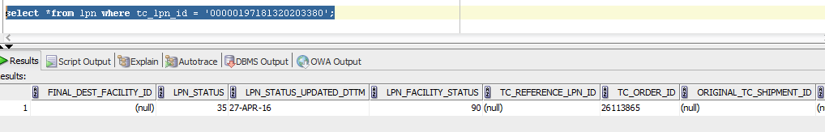

* Here lpn_facility_status (carton status) is 90 (Shipped).

We need to close the shipment through UI.

**Step 3:** Go to UI -> Shipments

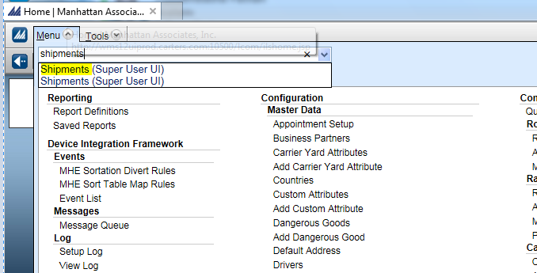

**Step 4:** Enter Shipment ID and Apply.

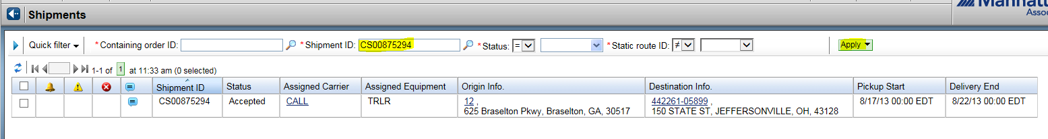

**Step 5:** Select Shipment, go to More -> Close Shipment

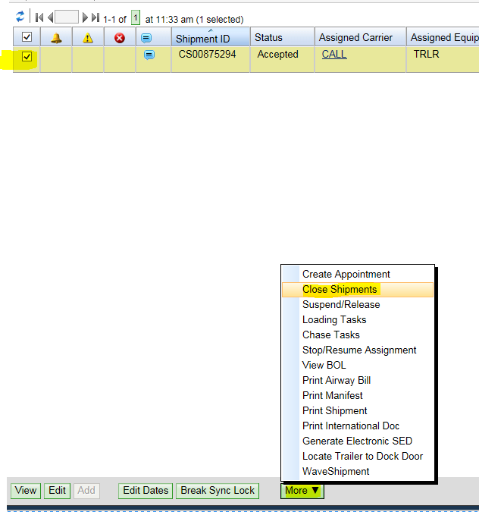

**Step 6:** Uncheck the ‘Invoice Trailer Contents’ check box and Save as shown in the below image.

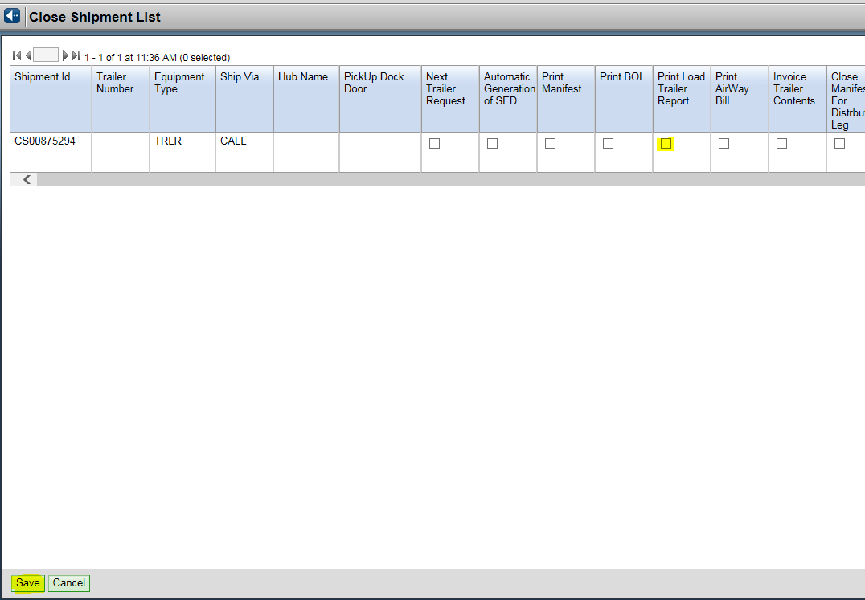

**Scenario 2:**

If in scenario 1 the shipment fails to close even after closing it from UI, we need to check whether the manifest number is present for that given LPN record.

select item_id,lpn_facility_status,lpn_id,tc_lpn_id,tc_order_id,manifest_nbr,

last_updated_source, order_id, TOTAL_LPN_QTY,

INBOUND_OUTBOUND_INDICATOR from lpn where tc_lpn_id in (‘’);

If the manifest number is **null** we need to manually update the shipment status to delivered (80). This should solve the issue and alert will stop firing.

UPDATE SHIPMENT SET SHIPMENT_STATUS = 80

WHERE TC_SHIPMENT_ID IN (‘’);

**Scenario 3:**

**Issue Description:** If user wants to close the shipment follow the below steps.

Attached is the reference mail for the same issue.



**Reason why they are unable to close shipment:**

Someone had gone in and removed the store number from the route.  This is why it would not close initially.  They should not delete this type of data from shipments.

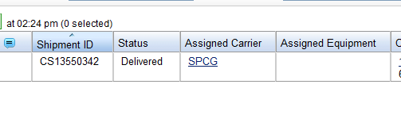

**Resolution:** Follow the same procedure from step3 to step 6 and when u close shipment, the next screen has a check mark for invoicing.   If you didn't uncheck it, close shipment will run invoicing so uncheck the invoice flag.